Bpm’online has several OOTB system tables you should be aware of to achieve successful results in advanced administration and development.
Database tables that store data on access rights
1. SysEntitySchemaOperationRight stores the data on what users and roles are entitled to make certain operations on certain system objects. These operations are CRUD:
- C (create) – enabled to create a new record in the object
- R (read) – enabled to see existing records in the object
- U (update) – enabled to edit existing records of the object
- D (delete) – enabled to delete existing records of the object
The table has the following informatory columns:
Column Name | Column Description
SubjectSchemaUId | Unique identifier of the object, managed by operations. The object for which access rights are set.
SysAdminUnit | Unique identifier of User/Role from [SysAdminUnit] for which the access right is specified.
Position | Indicates the priority of the rights stored in the table for specific object.  The range of valid values contains:  “-1” means the highest priority  “0” – is lower than “-1”  “1” – is lower than “0”, etc.
CanAppend | Possible values: “True”, “False”. Indicates that the user/ role is entitled to create new records if the value is “True”.
CanRead | Possible values: “True”, “False”. Indicates that the user/ role is entitled to see records in the object if the value is “True”.
CanEdit | Possible values: “True”, “False”. Indicates that the user/ role is entitled to modify records in the object if the value is “True”.
CanDelete | Possible values: “True”, “False”. Indicates that the user/ role is entitled to delete records in the object if the value is “True”.

This table stores information that is added/ modified on [Access to object] tab in [Object permissions] section.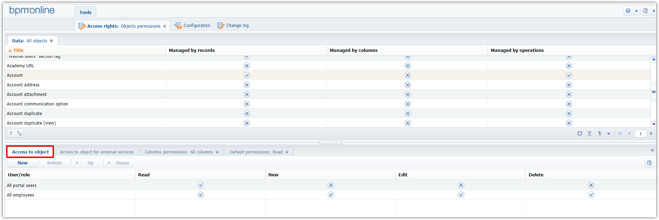

2. SysEntitySchemaRecordDefRight stores data on access rights distribution that is set by default for all new records of the object.
The table has the following informatory columns:
Column Name | Column Description
SubjectSchemaUId | Unique identifier of the object to which access rights are set.
SysAdminUnit | Unique identifier of User/Role from [SysAdminUnit] for which the access right is specified.
Author | Id of user/role from [SysAdminUnit] table who create the new record.
Grantee | Id of user/role from [SysAdminUnit] table who is entitled to work with this new record by default.
Position | Indicates the priority of the rights stored in the table for specific object record.  The range of valid values contains:  “-1” means the highest priority  “0” – is lower than “-1”  “1” – is lower than “0”, etc.
Operation | Indicates the operation with the new record that should be distributed to specified user/ role by default.  The range of valid values contains:  “0” – access denied  “1” – read access  “2” – edit access
RightLevel | This field value determines the level of default access rights to the record.  The range of valid values contains:  “0” – access denied  “1” – access permitted  “2” – access permitted/ delegation permitted

This table stores information that is added/ modified on [Default permissions] tab in [Object permissions] section.
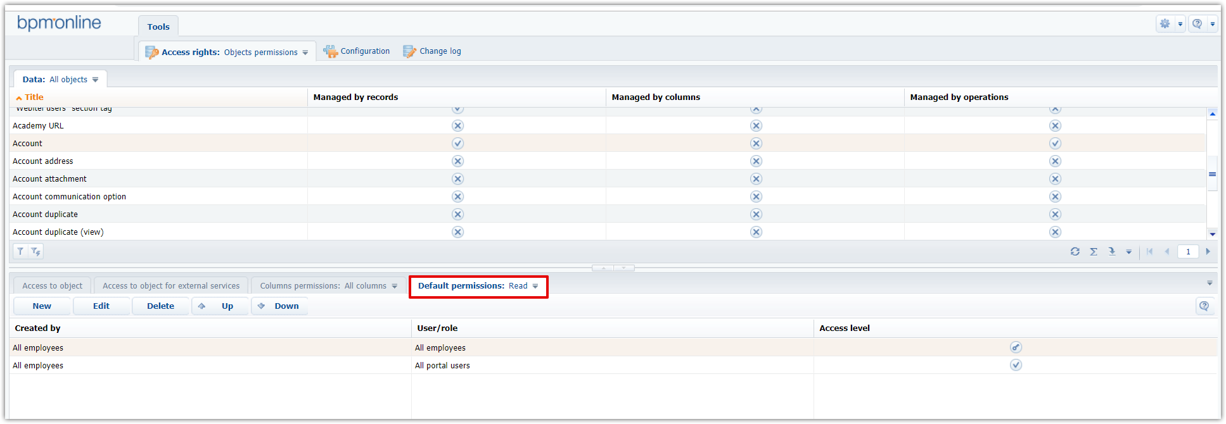

3. SysEntitySchemaColumnRight stores the data on access rights distribution to columns of objects.
The table has the following informatory columns:
Column Name | Column Description
ObjectSchemaId | N/A
SubjectSchemaUId | Unique identifier of the object to which column access rights are set.
SubjectColumnUId | Unique identifier of the object column to which column access rights are distributed. Can be seen in object metadata.
SysAdminUnit | Unique identifier of User/Role from [SysAdminUnit] for which the access right is specified.
Position | Indicates the priority of the rights stored in the table for specific object record.  The range of valid values contains:  “-1” means the highest priority  “0” – is lower than “-1”  “1” – is lower than “0”, etc.
RightLevel | This field value determines the level of default access rights to the record.  The range of valid values contains:  “0” – access denied  “1” – access permitted  “2” – access permitted/ delegation permitted

This table stores information that is added/ modified on [Default permissions] tab in [Object permissions] section.

Database tables that store data related to system settings
1. SysSettings table stores the full list of existing system settings.
The table has the following informatory columns:
Column Name | Column Description
Name | Shows the title of the system setting.
Description | Stores brief description of the purpose of the system setting.
Code | Uniquely defines the system setting in the system. The field value can consist of Latin letters and numbers only and must not contain spaces.
ValueTypeName | Indicates a type of system setting.  The list of possible types is:  - String (50 characters), String (250 characters), String (500 characters), Unlimited length string  - Encrypted string  - Date/time, Date, Time  - Integer, Decimal, Currency  - Lookup  - Boolean  - BLOB (image)
IsPersonal | If the value is “True”, it means that the system setting is configured for each current user individually.
IsCacheable | If the value is “True”, it means that the system setting value changes relatively rarely and thus must be calculated only once per user session.
ReferenceSchemaUId | N/A
IsSSPAvailable | If value is “True”, the system setting is allowed for portal users.

NB: to be transferred between development environments, the new system setting should be bound to some package. Add a new record on [Data] tab in configuration. Set [System setting] as object to bind data to.
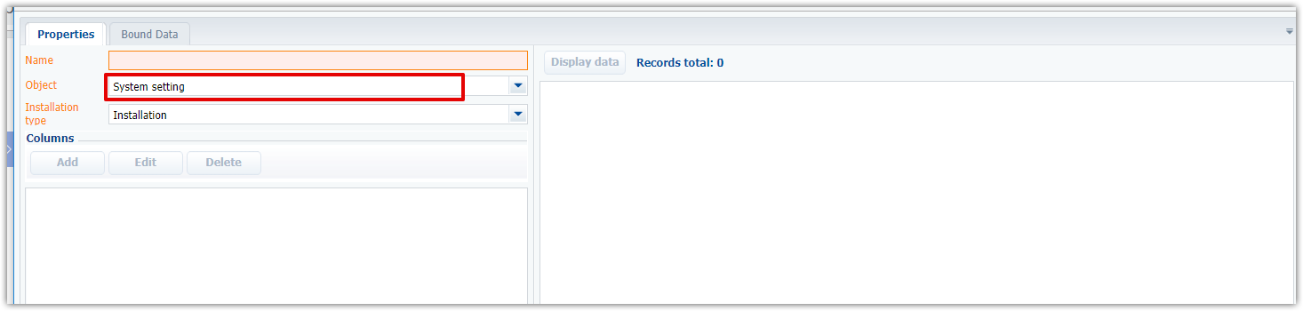

2. SysSettingsValue is a system table intended for storing of certain values of system settings.
The table has the following informatory columns:
Column Name | Column Description
SysSettings | Unique identifier of the system setting that owns the specified value
SysAdminUnit | Unique identifier of User/Role from SysAdminUnit for which the value is specified
IsDef | “True” indicates that the specified value is default for the system setting
TextValue | The field is populated with specified value for system setting with types:  - String (50 characters), String (250 characters), String (500 characters), Unlimited length string.  In all other cases, it’s empty.
IntegerValue | The field is populated with specified value for system setting with type:  - Integer  In all other cases, it’s “0”.
FloatValue | The field is populated with specified value for system setting with type:  - Decimal, Currency  In all other cases, it’s “0.00”.
BooleanValue | The field is populated with “True”/”False” value for system setting with type:  - Boolean  In all other cases, it’s always “False”.
DateTimeValue | The field is populated with specified value for system setting with type:  - Date/time, Date, Time  In all other cases it’s “NULL”
GuidValue | The field is populated with specified value for system setting with type:  - Lookup  In all other cases it’s “NULL”
BinaryValue | The field is populated with specified value for system setting with type:  - BLOB  In all other cases it’s “NULL”

NB: to be transferred between development environments, the specified system setting value should be bound to some package. Add a new record on [Data] tab in configuration. Set [System setting value] as object to bind data to. System setting value should be bound only in complex with the parent system setting.

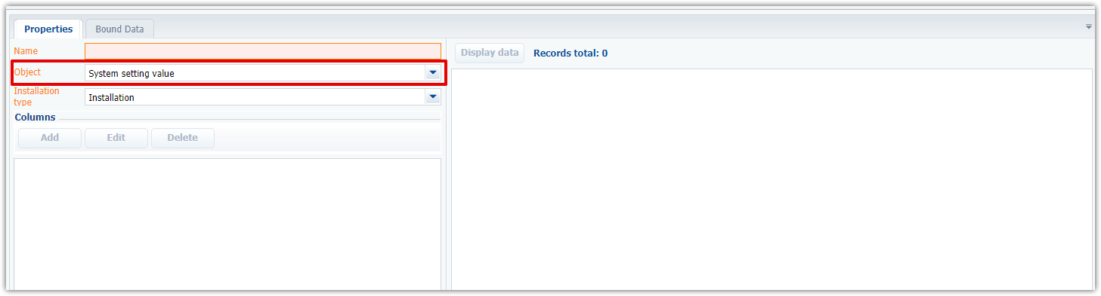

Database tables that store data ON operation permissions
1. SysAdminOperation is a system table that stores list of existing operation permissions.
The table has the following informatory columns:
Column Name | Column Description
Name | Shows the title of the operation permission.
Description | Stores brief description of the purpose of the operation permission.
Code | Uniquely defines the operation permission in the system. The field value can consist of Latin letters and numbers only and must not contain spaces.
SysFolder | This field indicates the specific group (folder in [Operation permissions] section) where the specific operation permission is stored. Represents a link to a record in [SysAdminOperationFolder] table.

NB: to be transferred between development environments, the new operation permission should be bound to some package. Add a new record on [Data] tab in configuration. Set [Operation] as object to bind data to.
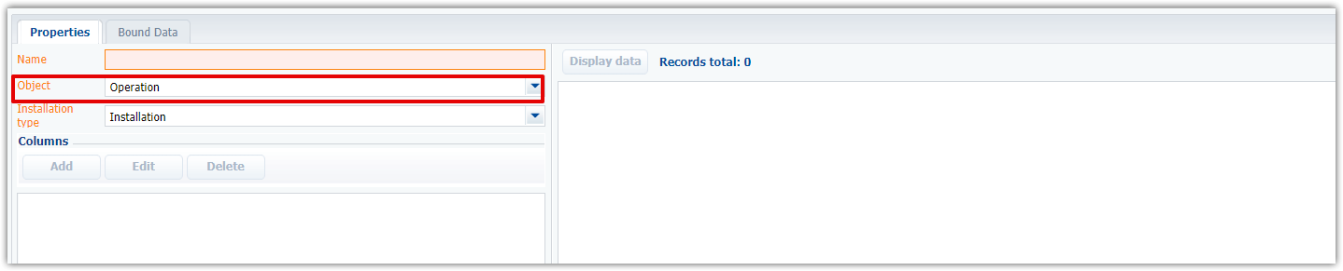

2. SysAdminOperationGrantee is a system table that stores list of users/ user roles that are entitled to execute any specific operation permission.
The table has the following informatory columns:
Column Name | Column Description
SysAdminOperation | Unique identifier of the operation permission
SysAdminUnit | Unique identifier of User/Role from [SysAdminUnit], listed in the operation executors.
CanExecute | The “True” value indicates that can execute the operation.
Position | Indicates the priority of the rights stored in the table for specific object record.  The range of valid values contains:  “-1” means the highest priority  “0” – is lower than “-1”  “1” – is lower than “0”, etc.

NB: to be transferred between development environments, the specified operation permission grantee should be bound to some package. Add a new record on [Data] tab in configuration. Set [Permission granted to] as object to bind data to.
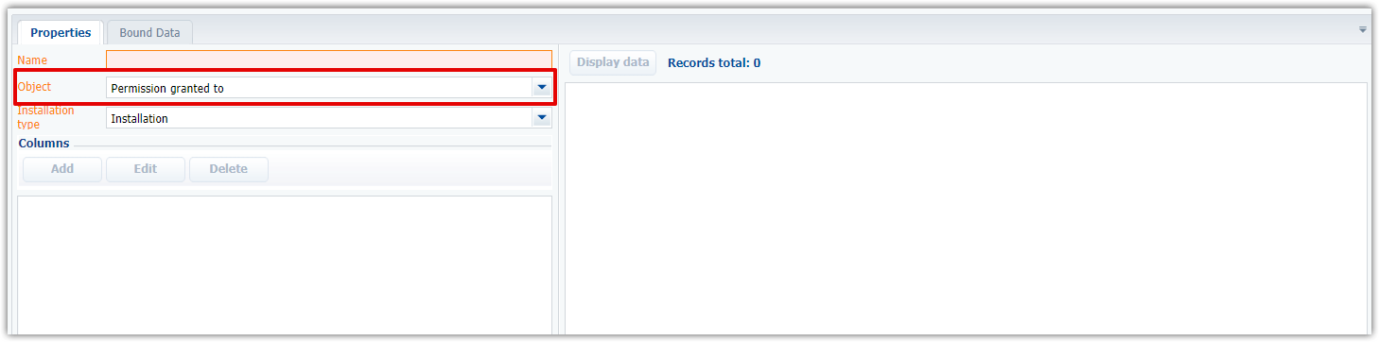

Database tables that store data ON Workplaces
1. SysWorkplace is a system table intended for storing the full list of user’s workplaces that are configured in the system.
The table has the following informatory columns:
Column Name | Column Description
Name | Shows the title of some workplace.
Position | Position of the specific workplace relative to other workplaces.
LoaderId | Represents Workplace loader schema, the link to Uid of SysSchema. By default has a value as ClientUnitSchemaManager.
SysApplicationClientType | The column indicates the type of client app where the workplace is utilized. It is a link to a system table [SysApplicationClientType] that stores only two values: “Browser” (for desktop app)/ “Phone” (for mobile app)

NB: to be transferred between development environments, the workplace should be bound to some package. Add a new record on [Data] tab in configuration. Set [Workplace] as object to bind data to.
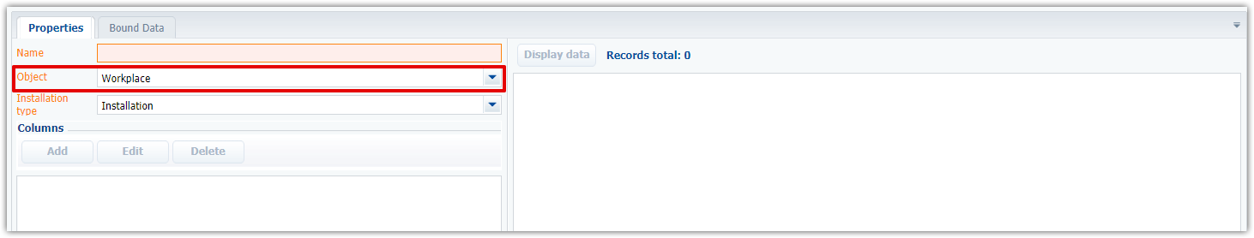
2. SysModuleInWorkplace is a system table that stores data on sections that are included in the specific workplace.
The table has the following informatory columns:
Column Name | Column Description
Position | Position of the module relative to other modules within single specific workplace
SysWorkplace | Unique identifier of specific workplace that includes the specified module
SysModule | Unique identifier of specific module that is included in some specific module

NB: to be transferred between development environments, the workplace should be bound to some package. Add a new record on [Data] tab in configuration. Set [Section in a workplace] as object to bind data to.
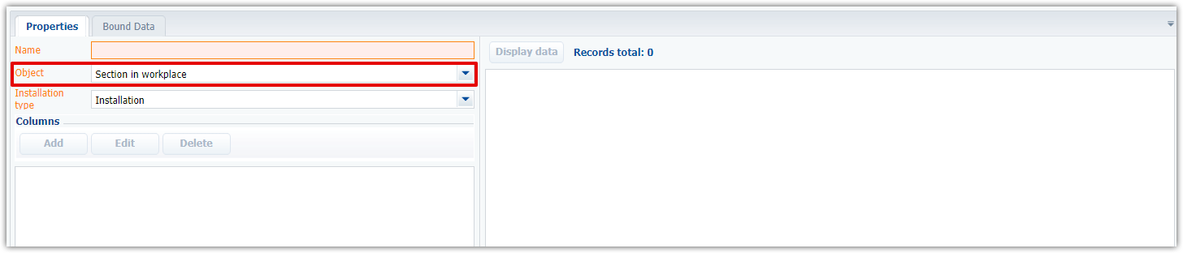

3. SysAdminUnitInWorkplace is a system table that is intended for data storing on access rights distribution to workplaces for users/ roles. Each user/role can have access to multiple workplaces. A separate table record is created to distribute access to each workplace for each user/role.
The table has the following informatory columns:
Column Name | Column Description
SysWorkplace | Unique identifier of specific workplace to which access rights are distributed
SysAdminUnit | Unique identifier of User/Role from [SysAdminUnit] that is entitled to work with the workplace.

NB: to be transferred between development environments, the table data should be bound to some package. Add a new record on [Data] tab in configuration. Set [Object in workplace] as object to bind data to.
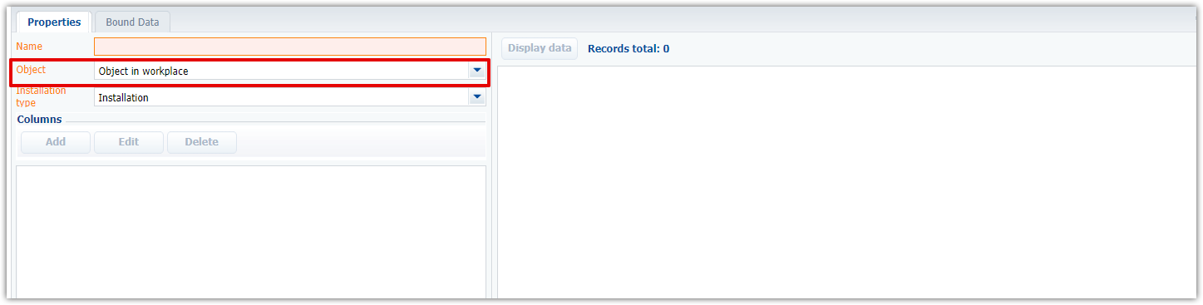

Database tables that store data ON USERs and profiles
1. SysProfileData is a system table that stores information on personal settings of all users, e.g. columns setup.
The table has the following informatory columns:
Column Name | Column Description
SysUser | N/A
ObjectId | N/A
Key | Indicates the component to which the SysProfileData record belongs to.  E.g., key ContractPageV2InvoiceDetailV2 stores data on InvoiceDetailV2 detail columns that is situated on the ContractPageV2 page.
ObjectData | JSON settings of profile. E.g., the configuration of the order and the width of columns or filter in the section.
ObjectDifference | N/A
Contact | Stores Id of user contact if the setting was configured personally from his profile.
SysCulture | A unique identifier of specified localization setting for specific user. Link to [SysCulture] table.

NB: to be transferred between development environments, the user profile settings should be bound to some transition package. Use the following workflow to achieve this goal:
- Save the columns setup for all users.
- Go to DB and search for the key of this SysProfileData record by query
  - SELECT * FROM "SysProfileData" ORDER BY "ModifiedOn" DESC:
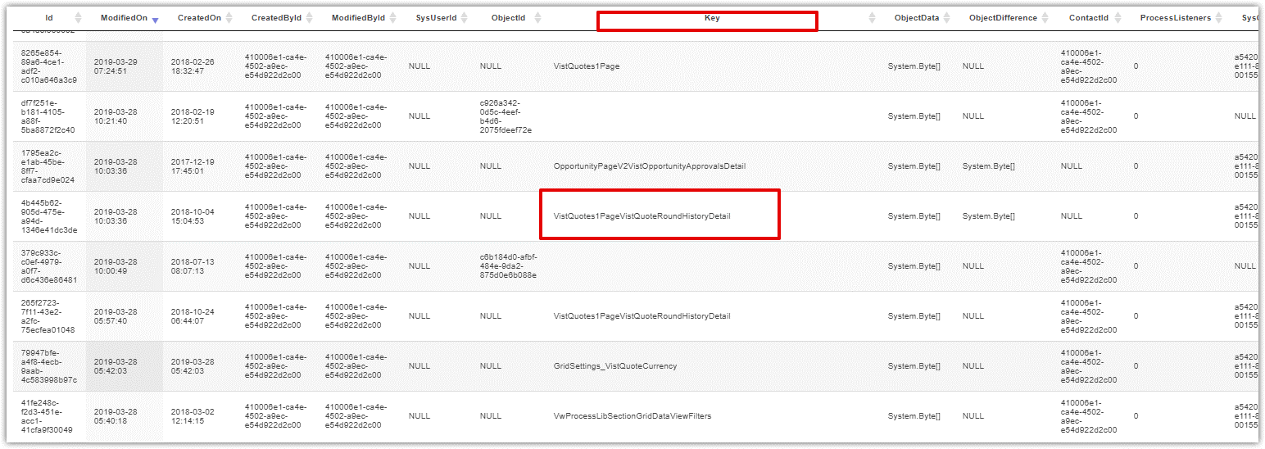
- Add a new record on [Data] tab in configuration. Set [User profile] as object to bind data to. You should merge SysProfileData record by Key (have got the value from the DB query), Contact and Culture fields:
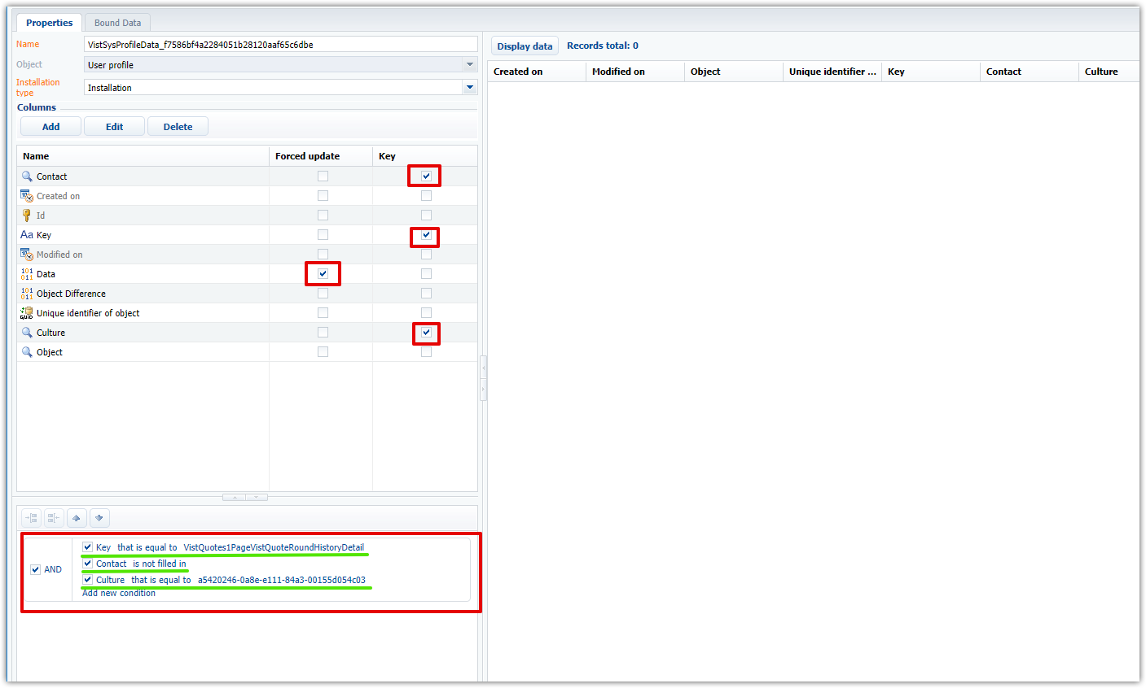

2. SysAdminUnit stores the full list of all roles and users of the system. Based on this table, the hierarchy of the organizational structure in the [Users] section is built.
The table has the following informatory columns:
Column Name | Column Description
Name | Represents a name of the user/ role
Description | Brief description of the user/ role
SysAdminUnitTypeValue | Type of organizational structure element. The field value is the link to the system table [SysAdminUnitType]. There are following possible values OOTB: “0” (“Organization”); “1” (“Division”); “2”(“Manager”); “3” (“Team”); “4” (“User”); “5” (“Self-service portal user”); “6” (“Functional role”)
ParentRole | Unique identifier of the parent role. Refers to the Id column of the current table
Contact | Unique identifier of the contact with which the specified user is associated. For roles, the field value is “Null”
Account | Unique identifier of the account with which the specified role is associated. For users, the field value is “Null”
IsDirectoryEntry | Indicates that an entity is a group in ActiveDirectory  “1” - is a group in ActiveDirectory  “0” – is not a group in ActiveDirectory
TimeZoneId | The time zone of specific user. Here one of “Code” field values from [TimeZone] table is specified. Or the field is empty.
UserPassword | Coded user password
Active | “True” value indicates the user’s account is active and user is able to log in the system.
SynchronizeWithLDAP | Indicates if the user will use credentials from ActiveDirectory service  “1” – user credentials from ActiveDirectory are used  “0” – user credentials from ActiveDirectory are not used
LDAPEntry | The name of the entity (user or group) ActiveDirectory, the credentials of which will be used
LDAPEntryId | The unique identifier of the entity (user or group) ActiveDirectory whose credentials will be used
LDAPEntryDN | LDAP server name
SysCulture | A unique identifier of specified localization setting for specific user or role. Link to [SysCulture] table
LoginAttemptCount | The number of user login attempts to the system. Corresponds to the value of the system settings "Number of login attempts" (LoginAttemptCount)  “0” - the number of attempts is not limited
SourceControlLogin | User login in version control system (SVN)
SourceControlPassword | User password in version control system (SVN)
PasswordExpireDate | The expiration date of the user's password to the system
HomePage | N/A
ConnectionType | The type of user connection  “0” – normal connection  “1” – self-service portal user  “2” – virtual login to the system
UnblockTime | The time-box after which the user will be blocked.  The field is auto-populated if the user account was blocked in response to exceeding the limit of login attempts using the wrong password. The field value is calculated based on the “User locking time” system setting value.
ForceChangePassword | Indicates forced password reset setting  “0” – do not reset user password  “1” – do forced password reset
DateTimeFormat | The field stores the link to [SysLanguage] table.
SessionTimeout | Personally specified user session timeout in minutes for specified user

NB: to be transferred between development environments, the specified users and roles should be bound to some transition package. Add a new record on [Data] tab in configuration. Set [System administration object] as object to bind data to.
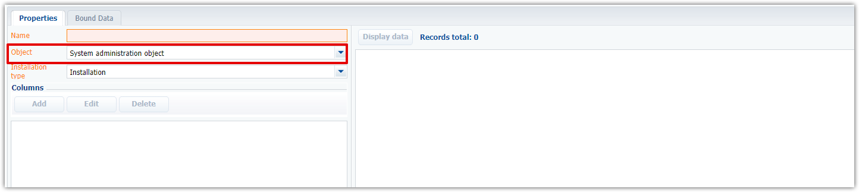

3. SysUserInRole is a system table that stores data on allocation of users between organizational structure roles.
The table has the following informatory columns:
Column Name | Column Description
SysUser | Unique identifier of the user. Is a link to the corresponding record in [SysAdminUnit] table.
SysRole | Unique identifier of the role to which the user belongs. Is a link to the corresponding record in [SysAdminUnit] table.
NB: to be transferred between development environments, the allocation of users between roles should be bound to some transition package. Add a new record on [Data] tab in configuration. Set [User in roles] as object to bind data to.
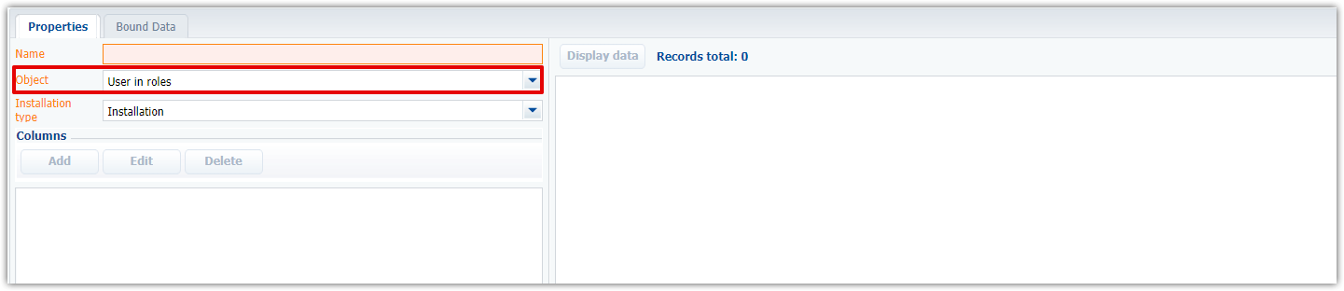

Database tables that store data ON LOOKUPS
1. Lookups is a system table that stores the full list of lookups that exist in the system
The table has the following informatory columns:
Column Name | Column Description
Name | Name of lookup
Description | Brief description of lookup and its purpose
SysEntitySchemaUId | Indicates the value of Uid in SysSchema for the lookup edit page
SysPageSchemaUId | Indicates the value of Uid in SysSchema for the lookup object

NB:
1. to be transferred between development environments, the lookup (registered in the “Lookup” section) should be bound to some transition package. Add a new record on [Data] tab in configuration. Set [Lookup] as object to bind data to.
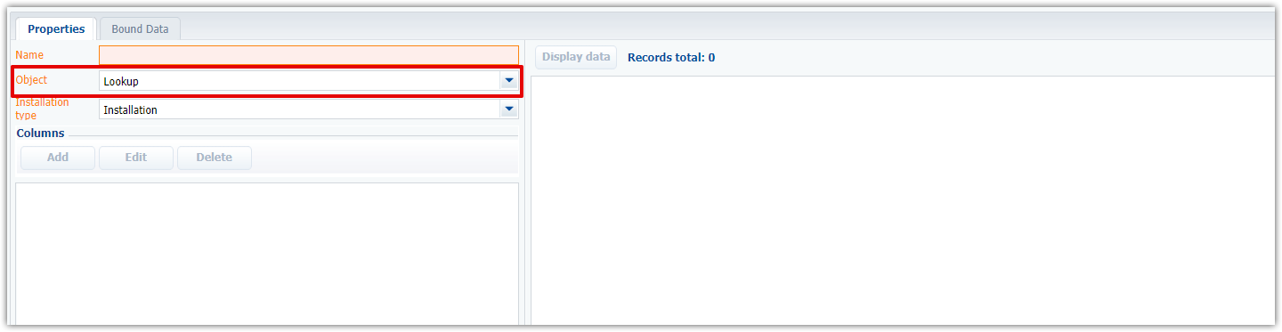
2. to be transferred between development environments, the lookup values (populated in the specific lookup) should be bound to some transition package. Add a new record on [Data] tab in configuration. As the object to bind data to, one should specify the object that corresponds to the registered lookup.

